Test instructions

# Parts

* Arduino Due
* Breadboard
* Sensor with frequency output of choice( in this case the tcs3200 color sensor )
* oled I2C display 128x64 (optional)
* 6x male to male cables
* 13x female to male cables

# Build

Build the circuit after the schematic pictured down below. The screen is not necessary and can be left out.

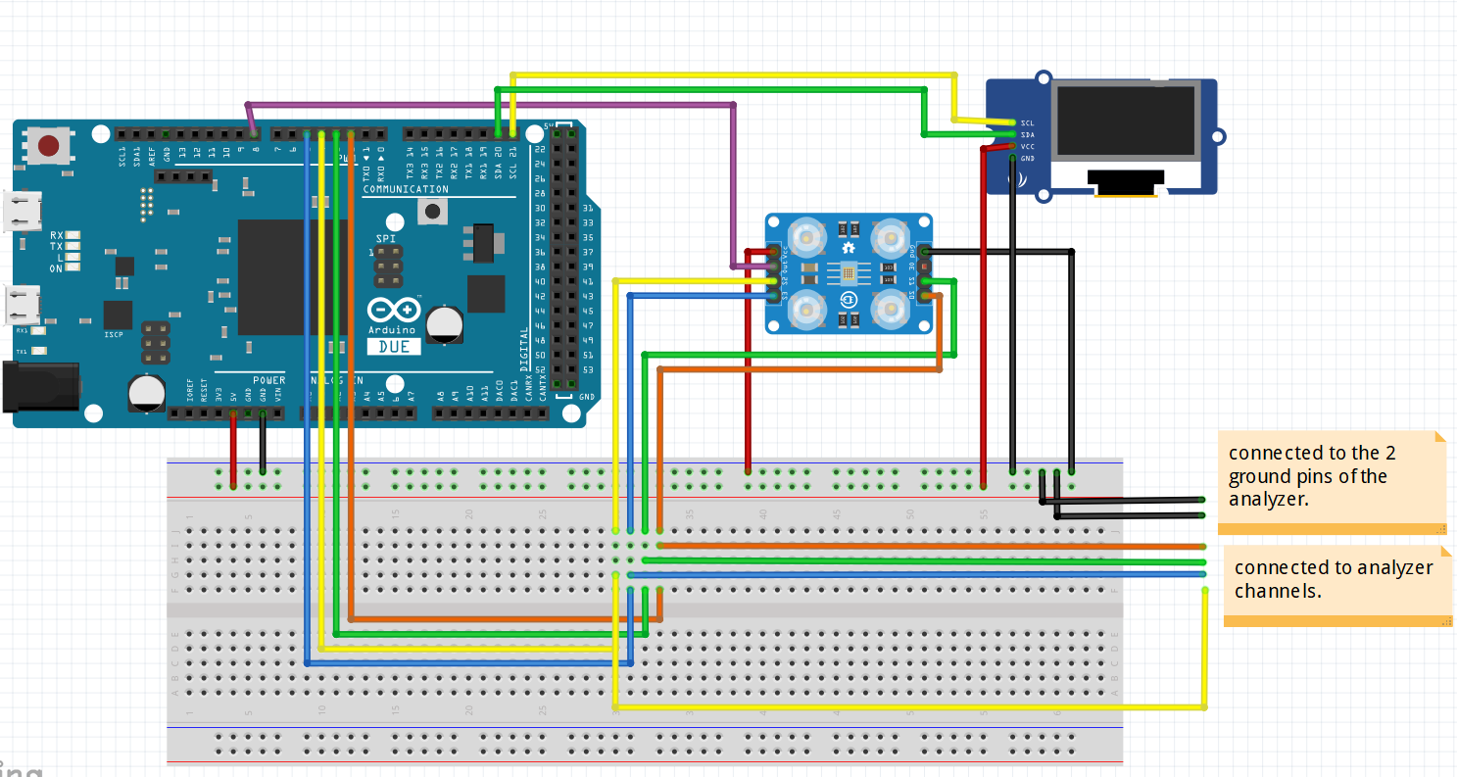

# Software test freqMeasurement

After buidling the circuit.

1. Connect the pins of the sensor to the analyzer pins.
   1. S0 to channel 1
   2. S1 to channel 2
   3. S2 to channel 3
   4. S3 to channel 4
   5. Output to channel 5
2. Place the test code into a main and run the code.
   1. The code outputs a frequency that it measures out of the input pin.
3. While the code runs open the analyzer software and start the test.
4. Channel 2 should be high and channel 1 low. The fifth channel should show a square wave. If channel 1 is not high it will not put out a wave and the cable of channel one should be replaced.
5. In the software of the analyzer if you hover your mouse over the created frequency chart of channel 5 it will show the frequency in kilohertz. Compare the outputted frequency with the frequency that is shown in the logic software.
6. If the code works and the build is correct the given frequency from the code and from the analyzer software will match.

# Software test colorSensor

After building the circuit

1. Run the test code for the colorsensor
2. It will output the frequency of the RGB values, colorzone’s and colorname.
3. It can be tested using items of the corresponding colors.
4. If the color name is wrong check the color zones printed on screen with the ones in the color name mode function and changes the values if necessary.

## Hardware test

1. Testing the Arduino:
   1. While uploading the code the tx light of the Arduino will blink. If this doesn’t happen the Arduino is broken and must be replaced.
2. Testing the wires.
   1. Output a high signal through the wire and into a led. If the led burns the cable is functional, otherwise it should be replaced.
3. Testing the sensor
   1. If the leds of the sensor don’t burn the sensor is broken and should be replaced. If the channel 1 on the analyzer is high but it does not output a signal the cable should be tested. If the cable is functional the sensor is broken and should be replaced.
4. Testing the screen
   1. If the screen is connected properly and the application code is run it should show a character and four health bars. If it does not check the cables if the cables are functional the screen is broken and should be replaced.

# Testresults

After building the circuit as pictured in build.

|  |  |  |  |
| --- | --- | --- | --- |
| Test | Expected result | result | Test successful |
| Freq Measure test | The given Hertz from the code and the measurement form the analyzer software are a close match. A close match means a difference of maximum 10 hertz. | After measuring 5 times. The average difference is about 7 Hertz. | The test result is successful. |
| Color Sensor test Mode1 | The three colors in this mode can be defined successfully 8/10 times. | The color red is recognized 9/10 times. Blue and green are sometimes confused but are accurate 8/10 times. | The colors are successfully identified 8/10 times. |
| Color Sensor test Mode2 | The 7 colors in mode 2 should be identified correctly 7/10 times. | The colors red, green and blue are correct 8/10 times. Pink, brown and orange are correctly identified 7/10 times but can be confused for one another. One a white service surrounded by yellow light the yellow color can be detected from white obejcts. | Successful but keep ambient light in mind when conducing tests. |
| Light intensity test | The light intensity should drop when the sensor is obscured from light. | The light intensity is dropped from around 4000 to 300 when the sensor is obscured from light. It will not drop lower due to the attached led on the sensor itself | Successful, but keep the attached led on the sensor in mind. |